# Tableau Dashboard Team Project Handover Summary

## **1. Analytics Team**

*- Team members:* Anh Quan Hua (Project Lead)

Nithini Bogahawattha

Xiaolu Li

Gouri Nandan Reddy Gangavaram

## **2. Project briefs and Summary**

### a. Analysis on Fitness Tracker Sales dataset

*- Time:* Week 3 to 6

*- Summary:* Our team performed a comprehensive analysis on sales data of smart wearables, collected from an E-commerce website of the India market. The purpose to find out about consumers’ spending behaviors and determining factors that would affect their choice of fitness trackers. We later utilized this to showcase the different templates that our Tableau Dashboard can be done using this dataset as an example.

*- Relevant document:*

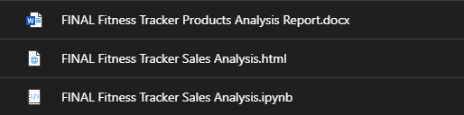

### b. Tableau Dashboard Template Implementation

*- Time:*  Week 6 to 8

*- Summary:* Our team created different Tableau Dashboards based on various open-source datasets to demonstrate the flexibility and power of Tableau. These Dashboards can be used as Templates in future project – in the case that the overall data structure remains the same as the one used your desired Dashboard.

*- Relevant document:*



### c. Tableau Dashboard Guide

*- Time:* Week 8 to 10

*- Summary:* For the final project of the semester, our team wanted to produce a document where we each create a guide that provides tips and directions to create Tableau Dashboards. The guide will begin from scratch, with the process of receiving the datasets, and end with a section that provide an example of Dashboard creation along with how to use existing Dashboards as templates.

*- Relevant document:*

